Installing the VMware Horizon Client

If you need to use the VDI Client instead of the recommended HTML method, please follow these instructions to install the Client on Windows 10. The VDI Client for Mac is also available for download at the link below. Configuration steps will be similar as to those shown here.
Please NOTE that the recommended version of the Client is 5.4 for Win 10, Mac, and Android. IOS is still at version 5.3. IOS users are encouraged to use the HTML connection method through Safari until 5.4 becomes available.

Instructions for Windows 10:
- Download the latest version of VMware Horizon Client by clicking on the following link:
https://my.vmware.com/en/web/vmware/info/slug/desktop_end_user_computing/vmware_horizon_clients/5_0
- Under “VMware Horizon Client for Windows” you can find a link titled “Go to Downloads” which takes to you the download pages
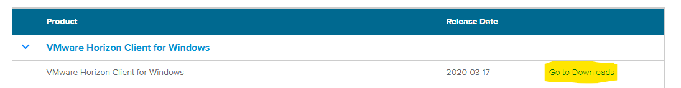
- Press “Download” and save the installer file on your local disk drive.
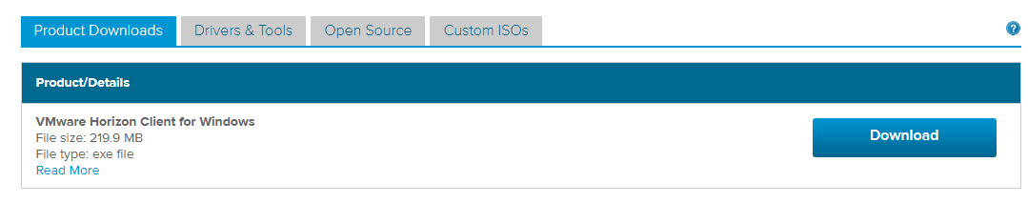
- Once the download is completed, open the installer file. You should see the installer prompt which is like the following
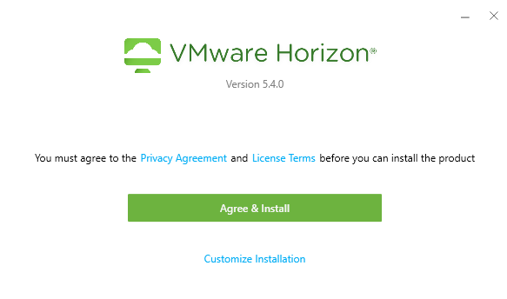
- By pressing “Agree & Install” the installer begins the installation process.
- At the end of installation, it asks for restarting the machine. Save and close your other documents and hit restart now (This step is optional, but it is recommended for best performance)
- You can find VMWare Horizon Client in the start menu and your desktop. Start VMware Horizon Client and the application starts. You should be able to see the following:
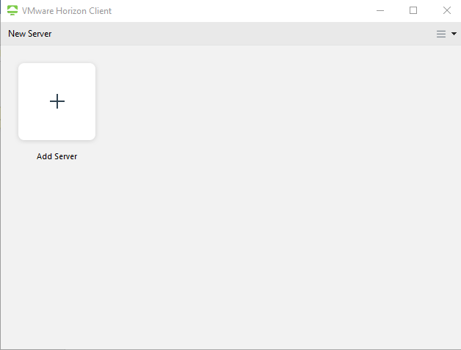
- On the top right corner, you can see the menu Icon. Click on that and select “Configure SSL”
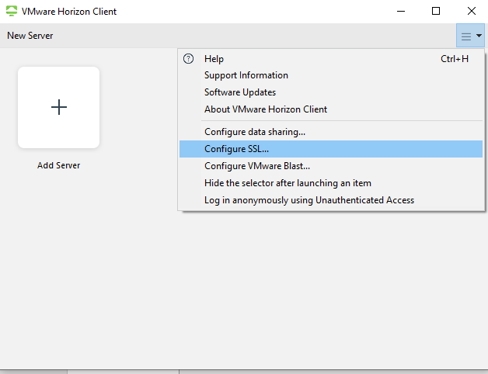
- Check “Allow connections via an SSL Proxy” and hit Ok.
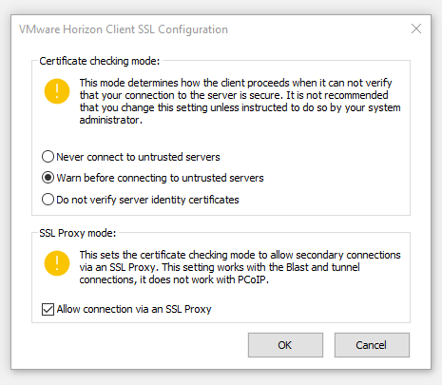
- Click on “Add Server”. Then enter https://vdi.washburn.edu in the box. Then hit Connect.
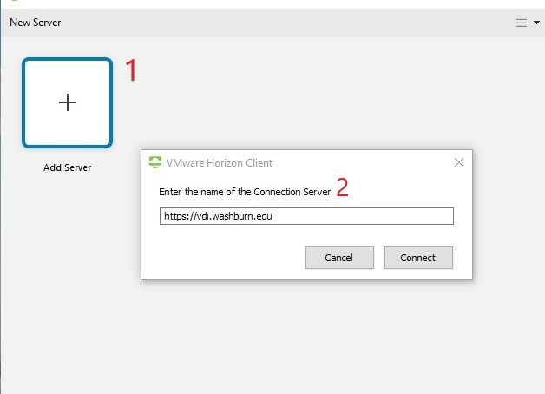
- Enter you WUAD credential as first.last@washburn.edu and your password.
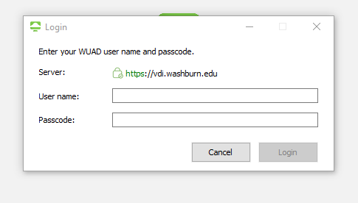
- Once you hit Login you should receive a push notification on your smart phone from Duo Security. Hit Approve on your phone to authorize the access. If everything is setup properly you should be able to see the following window:
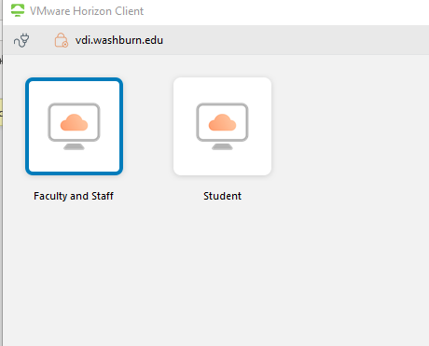
- Depending on your user type double click on the instance type to lunch a new one. You may see the following prompt:
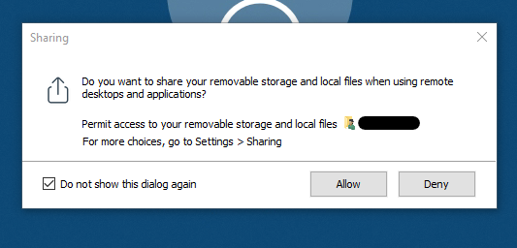
By selecting Allow you will have access to your local hard drives and USB drives in the remote machine which can be useful in moving files between your personal computer and the virtual instance. Please note that selecting Deny will not stop the virtual instance from working and it is totally optional.
- If everything went well, you should be able to see your desktop:
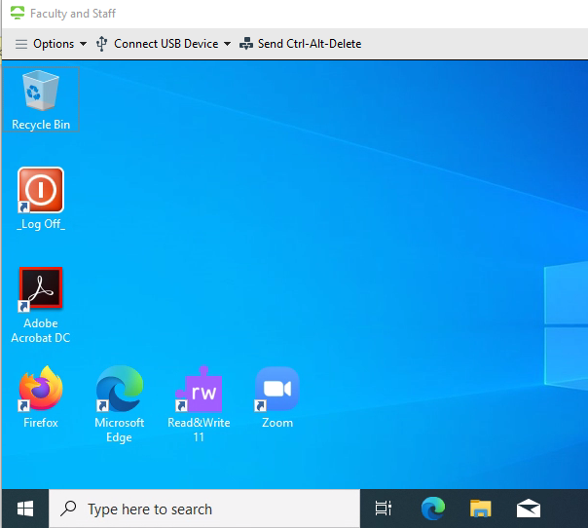
- You can have access to your personal home drive and public share drive by opening the File Explorer.
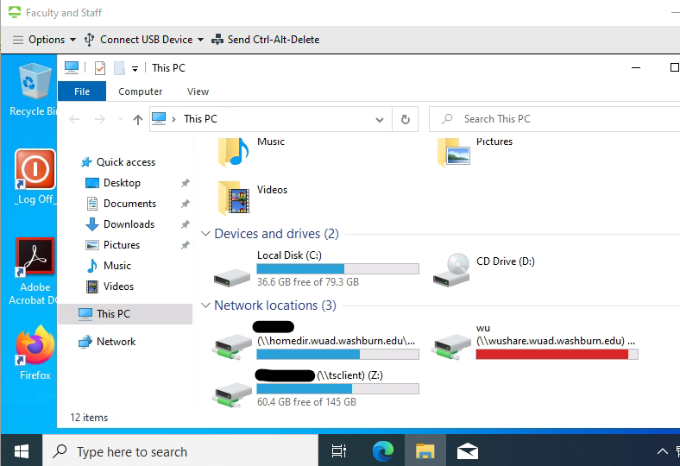

- To sign out and end the session hit “_Log Off_” on your virtual instance’s desktop
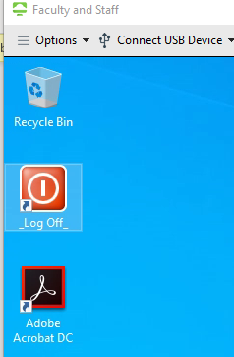
- To end you VDI experience session, hit the plug icon at top left corner and select Ok.
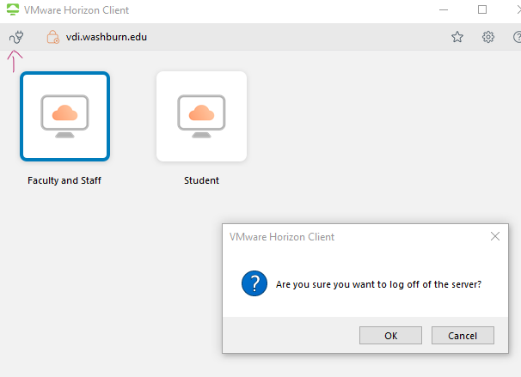

- The Washburn VDI service should be added to your server’s list. Next time you can start a new instance by clicking on vdi.washburn.edu and entering your credentials.
