Kansas Governors Recorded History and Documentary Project. Dr. Bob Beatty and Washburn University Governor William Avery, interviewed December 5, 2003

Interview with
governor William avery
december 5, 2003
wakefield, kansas
Governor of kansas: JanUary 11, 1965 - january 9, 1967

interviewed by dr.bob beatty
Department of Political Science
Washburn University
Topeka, Kansas 66611
Bob.Beatty@washburn.edu
785-670-1736
This interview with Governor William Avery is part of the Kansas Governors Recorded History and Documentary Project. All the subjects interviewed agreed to make the recorded interviews and transcripts available to the public for use in research, teaching, TV and film production, and other uses of benefit to future generations (signed release forms are on file at Mabee Library, Washburn University and the Department of Political Science, Washburn University from all interviewees). Therefore, anyone interested in using this and other interviews – filmed and printed – from the project are allowed to do so without needing permission from the subject or the project coordinator, Dr. Bob Beatty. However, we do ask that if your use of the interviews is published or shown to the public in any fashion, that you acknowledge and/or cite the source in the following manner: Kansas Governors Recorded History and Documentary Project, Dr. Bob Beatty and Washburn University.

Dr. Bob Beatty, Producer, Kansas Governors Recorded History and Documentary Project

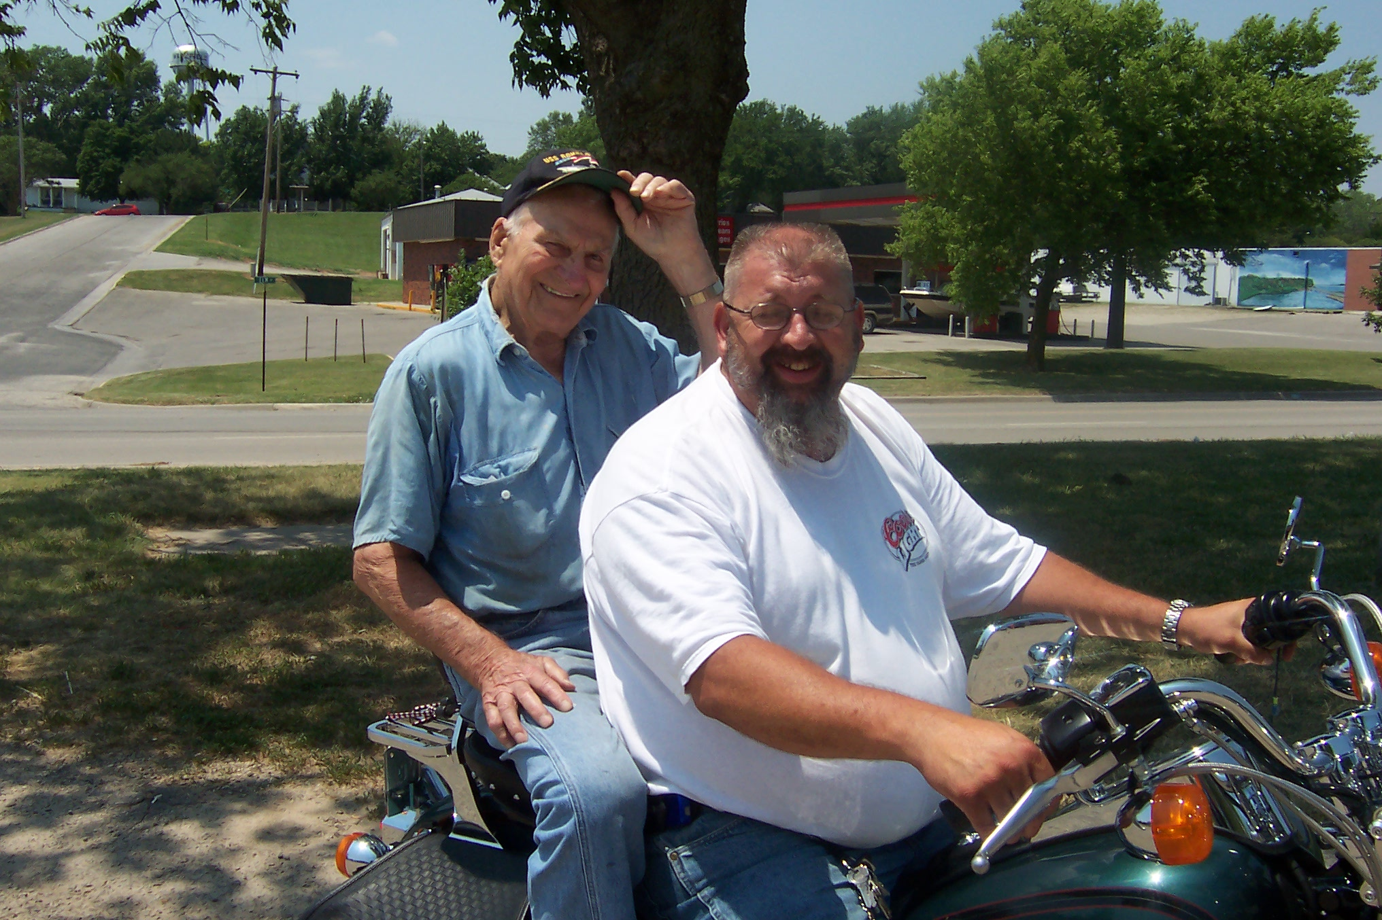

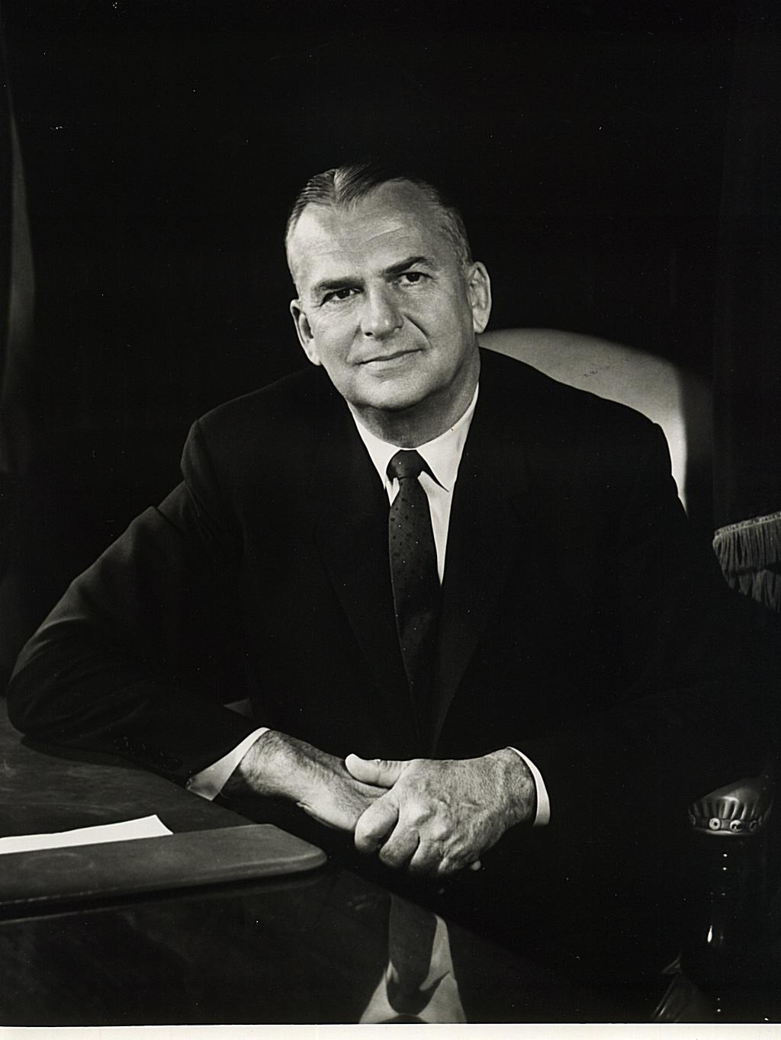
Governor william avery of kansas, 1965
Kansas Governors Recorded History and Documentary Project. Dr. Bob Beatty and Washburn University, 2005. Governor William Avery, interviewed December 5, 2003
Q. Could you tell us a little about where you grew up and what your life was like as a boy?
A. As a farm boy?

Q. Yeah.
A. I can tell you all about it. In fact, I can show you where I grew up. We can go up on the second floor and look down over the bluff and I can show you the corn field that is now visible because the reservoir is so low that that field is in sight. And that's where I grew up.
Of course, the improvements were just on the elevated level, one above that, level one of the improvement didn't overflow. But that field that I'm talking about, it flowed every time the river got high. Mostly just backed in and didn't overflow except in 1935. In 1935 of course a wall of water about six feet came rolling down and it didn't wait to back in to overflow the field, it just ran over it. But I hated to lose the farm to the Milford Reservoir. And it was a highly improved farm.
I can't really take issue with it because it enhances Kansas' supply of water, like all the other reservoirs, I include Tuttle Creek and the Perry Reservoir. We were all tied together in this fight. So we were all three in the same project. And I think time will make clear that these reservoirs were an economic benefit to Kansas despite all of the land that was taken off of the tax rolls and the income from that land.

Q. Let me ask you, what was your life like as a young boy? What was your school like and what would an average day be for a young boy on the farm?
A. Well, you'll have to refine your question a little bit. What do you mean? I could talk for 15 minutes on it. In what aspect do you mean?

Q. Well, tell us about your schools you went to.
A. Well, I grew up, of course, on a farm just down the hill from here. But my father grew up just a little ways north. And his father organized a country school district up there. And that's where my father went to school. And the school building there is-- I will get into that a little later. But this area down here was in the Wakefield Elementary School District. So I went to elementary school and high school in Wakefield. And then came college. And my father and mother were both college graduates, which is a little unusual for their age. My father was a graduate of Kansas State. He lived just across the river from it you might say, 25 miles. My mother graduated from the College of Emporia, they called it at that time. I guess it still has a name something like that. And she came to Wakefield to teach school and that's how they met.
My wife came to Wakefield to teach school 40 years later. That's how we met. And so we were both farmers, both married school teachers and both our marriages lasted 63 years. I think theirs didn't last that long because my father died quite a few years of age younger than I am now. So their marriage probably lasted 50 years.
I got off the track there because I wanted to say that-- I mentioned my father graduated from K-State. And practically all of the high school graduates that went to college, of course, went to Manhattan because they could almost walk there. I'm exaggerating, but it was before the reservation extended. It was only about 22 miles away. Now it's almost double that because you have to drive around it. You found that out on the way out here probably.

Kansas Governors Recorded History and Documentary Project. Dr. Bob Beatty and Washburn University, 2005. Governor William Avery, interviewed December 5, 2003
I thought a lot about college and I heard so much about Kansas State. My father bragged. He went to a few football games and he was on the Board of Alumna and Alumni Association, blah, blah, blah. And he always had a first name acquaintance with the President of K-State. And my brother and sister went to school there. And I came along and I decided I would like to do something a little different than that.
So as I have said publicly, I got on a train and I didn't get off at Manhattan. I just rode on down to the next college town. That is a little of a misstatement because Washburn would have been between. Let me apologize. But at that time I don't think I ever heard of Washburn. This was 1929 I'm talking about. I decided to go to the University of Kansas. And I'm not sorry that I did when I got into politics. It was not in my congressional district but I developed a very solid support group in Manhattan in Riley County despite having been a KU graduate. And then I had my KU friends, who are kind of scattered all over Northeast Kansas. So it kind of gave me a double base to campaign on. So I have to apologize to a lot of my friends around here because I didn't go to K-State as most of them did. But I have no regrets. I was very happy there.
I also had intentions, not commitments, but intentions, of possibly being a lawyer. And so that was another attraction to me of KU because I knew it had a law school. I don't know, Washburn may be older than the one at KU, I don't know. But I didn't know about it then anyhow. But I decided not to go to law school. I decided I was taking some pre-law courses in the college, and that went all right. But then I had almost enough credits to graduate so they permitted me to enroll in law school to take two or three courses. I decided then I didn't want to be a lawyer after I had two or three courses. They resented my being there I found out later. The law school resented anybody enrolling in law school if they weren't going to be a full-time law student. So I know they didn't try to make me comfortable and they sure didn't.
I will remember this as long as I live. The first day of class the professor came in with a big stack of cards. He would call the roll taking one card at time and mispronouncing part of the names. I was accustomed to that because I was in my fourth year when I was over there. But the first day over in law school the professor came in, folded his hands and sat behind his desk and said, “I will now call the roll.” And he sat there and called the roll without ever looking at anything. And I thought, “Boy, if this is what law school is like, I'm not sure this is for me.” Well there were other reasons, of course, but that did shake me up a little bit. After seeing professors for three and a half years over in college and they had been there a lot longer than I had and they were still using cards to call the roll, maybe about the same size class, I think. But this professor came in, didn't smile, just folded his hands and said, “I will now call the roll,” and waiting for people to answer every time he called a name. But that's a poor excuse, probably there were other reasons, but this is the reason I give for it.

Q. What prompted you later to run for the state legislature?
A. Well it goes back to Milford Reservoir. I came out early and obviously you can see my improvements, I had probably one of the bigger farms in the county at that time. And so obviously I had been farming at that time. I came right back from college and took over the farm. That was in 1934 and this came along in about 1954, before it really got serious, and a little later, in the late 1950’s. I evolved as kind of a spokesman for the lower part of the Republican Valley as opposing the reservoir and being in that group I became acquainted with a lot of people over at Tuttle Creek who were opposing Tuttle Creek. So when it began to get heated up some, why I knew that group and we worked together rather effectively. Well, I won't say effectively because they built both reservoirs, but we worked very hard at it, and mostly at our own expense. I think I got reimbursed for one trip to Washington and I made three or four.
Kansas Governors Recorded History and Documentary Project. Dr. Bob Beatty and Washburn University, 2005. Governor William Avery, interviewed December 5, 2003

But I got introduced to Washington, to the committee system and to the overall arrangement on Capitol Hill. But I don't think that had much impact on me had it not been for evolving as a leading opponent to the reservoir system. And I should say too, that we had the 1935 flood and we were concerned about floods and dikes along the cities of Topeka and Manhattan. Nobody was thinking about a shortage of water at that time, it just seemed like we had more water than we knew what to do with. And so my later appreciation of Milford Reservoir wasn't even thought of at that time. It was just, we didn't want to have to be dislodged for somebody else's convenience. That was a kind of selfish attitude, as I say I don't apologize for it. Being the third Avery owner of the farm, I didn't have it given to me. I was raised so I could acquire the other interest in it. And I was happy here.
I was encouraged to run for state legislature. I was encouraged because local people appreciated what I had done. They weren't very happy-- I won't say it that way, but they thought they could be better represented, I'll put it that way. So I was encouraged to run.
I'll never forget the day I had the crew getting ready to go out and bail hay. We had tractors and wagons and the crew just ready to leave to go to the field and here were these people from Clay Center down asking me to run for the state legislature. I said, “Well, I hadn't even thought about it.” I criticized my father, who I'm very fond of, for being away from home so much. I just stayed here and I got kind of my plan not to leave. Well, they gave a lot of reasons why they thought I should run. I said, “Okay, I'll make a deal. If you will guarantee I won't have a primary I'll probably consider to run, but I don't want to have to campaign at a primary and then possibly campaign in the general election.” They came back in about week and said, “We got it fixed, you won't have a primary.” I said, “I hope you know what you're talking about. It is a little hard to control who might want to run for the legislature.” They said they were sure nobody would run against me. That's the way it happened. And Clay County is one of the strongest Republican counties in Kansas, I think number one, two or three, so I didn't even have an opponent in the general election, and I didn't have an opponent when I ran for my second term.
I don't know how much detail you want on this, but Albert Cole had been congressman from Northeast Kansas and a very popular one. He had gone through the tough years of Truman and he was there just one term under Eisenhower. I can't remember if he ever had an opponent, a very effective opponent anyhow. I was always for him so I wasn't really concerned about him very much because he was conceded in this district he was going to be reelected. But Tuttle Creek came into his defeat. In the Blue Valley and Republican Valley action, he’s opposed to Tuttle Creek and he’s opposed to Milford, and that made him pretty solid in this area. And then after the 1942 flood that came along, why there was a lot of damage downstream, and that revived the downstream support for the reservoirs. I knew Albert and I didn't interrogate him very seriously on this, but he gave me the impression he voted against putting this money in for Milford and Tuttle Creek. But he didn't get up and oppose it.
And that turned on the so-called “Blue Belles” from the Republican Valley. I don't suppose you remember that name, but it got quite a sensation at that time. They called themselves the “Blue Belles from the Blue Valley”. They went out and campaigned against Albert in favor of a Democrat from Brown County who had never held public office before, except the local school board or city council or something like that. Howard Miller. I got that on my own. He defeated Albert Cole.

Kansas Governors Recorded History and Documentary Project. Dr. Bob Beatty and Washburn University, 2005. Governor William Avery, interviewed December 5, 2003
And so that kind of set the stage for some other Republicans to run against Mr. Miller, and I had achieved some recognition in the opposition side. I could say that I've always been against the reservoirs, I'm just not against it because Howard Miller was against them. And I got to run against him because I had a history in the opposition and I was known in the Blue Valley and Perry Creek river valley. And I was known and so I had kind of a basis of support to run for Congress.
And I had some opposition. My main opponent was from Topeka. And I knew my opponent. We were not close friends, but he had been a legislator, not with me, but he was there before and got acquainted around Topeka. And so I knew I was going to have some strong opposition. But it went along and I had four or five opponents. And I think that the two of us got most of the votes, most of the republican votes. And so I went in the [primary] election against Doyle Hawks, who was the other Republican candidate and supporter of reservoirs. And that gave him a solid base in Topeka because Topeka had been devastated by 1935 and damaged by 1942. And so it came down to that contest. I didn't win overwhelmingly, but it wasn't a squeaker. I think by several thousand votes I won. I should look that up.
And then of course I had to run against this incumbent, Howard Miller. These Blue Valley Belles got a lot of publicity by campaigning for Howard Miller, saying he stopped Tuttle Creek. He didn't, Eisenhower took it out of the budget, that's what stopped it. He got the credit and was there and opposed it and Albert lost it. And Albert doesn't say this to me, but he was quoted as saying those Blue Valley women are the ones that defeated him. You could see that it aroused a lot of publicity for a bunch of women going out and campaigning. In Kansas women hadn't been too much involved in campaigning, and the news media all picked it up and reported on all the campaign tours these ladies made and quoted this and the other thing. Albert told me, he said publicly, he gave the Blue Valley ladies, the Blue Valley Belles they called themselves, the credit for defeating him. And then when I came along, it gave the Blue Valley Belles quite a problem because I had been their friend and they had supported me. But some of them thought that they owed Howard Miller something. I still carried Riley County but not in the proportion that I did later after Howard Miller wasn't on the ticket anymore. So now you ask a simple question and I gave you an excessive answer. But that's how I got in politics. And I don't regret it.
I had a young family. I had a daughter two, a son four, and another daughter who was 12 and Bill, my oldest son, I think he was 14. And I was gone a lot in the summer of 1954 campaigning and I didn't realize the responsibility that left to my wife to take care of four kids with 10 or 12 years disparity in age. She wasn't on a budget and she always had a lot of help. I said you don't need to have me worry about that, so I can spend all my time on the campaign. I didn't realize until in recent years the responsibility she had in raising four kids and especially with that age disparity. She had to make sure that they got to school and all the other things that go along with being a parent to school children. And she had that all to herself for six months.
And I think it is appropriate to say here now. She's handicapped in a nursing home and I go to see her every night. I say it not for the conventional reasons, it's mostly because retrospectively I can appreciate the responsibility she had raising four children and having them all turn out to be great friends and children that are concerned about their parents. And I can't take much credit for that, a few genes perhaps. But as far as the day by day responsibility of raising a family, she has that all. I was home on weekends, blah, blah, blah, but the kids were glad to see me and take them for a horseback ride or something, but that's not being a parent. But from then on, the kids pretty much grew up in Washington. We were there for ten years.

Kansas Governors Recorded History and Documentary Project. Dr. Bob Beatty and Washburn University, 2005. Governor William Avery, interviewed December 5, 2003
Q. Why not stay there forever, why did you decide to come back and run for governor?
A. Well, like Strom Thurmond. He went to the Senate same year I went to the House. We had what you would call it the “84 Club.” That was the congressman and new senators and new members of the house all had this little club. It wasn't a big organization. Republicans had a bad year the year I was elected, of course, so there weren't that many Republicans and the Democrats were there and they never left. So there were quite a few of them. But we had a happy organization.

Q. I guess I mean you probably could have stayed in office up in Washington maybe for a long, long, long, time. Why did you decide to come back and run for Governor?
A. How many former members of Congress do you ever hear about? I had been in the legislature and it was then that I appreciated the authority and the direction that a Governor gives the state. Ed Arn was the Governor and those were boon times, there were no financial problems. The sales tax had been enacted before him so all he had to do was count the money. And he, he had his problems, but they were not difficult ones, they were political problems, not budget problems or unemployment problems, all of those conventional things we hear about today.
My dad had been in the state senate before I was born. He used to talk about it and later he was on the Board of Agriculture for 40 years. So he kind of stayed in touch with state politics and state government. And because of his long association with the party, most of the gubernatorial candidates showed up here some time before they announced or soon after, so I kind of knew who they were.
And I don't think anybody that didn't make this decision would admit they ever thought about it. On the other hand I would say I think they all thought about it after they got in the legislature. And to see the role, firsthand, see the role that the Governor played not only in recommending and having to work for the passage of certain legislation, but he was also a public figure. And 125 representatives, if you knew the one that was next door, why you knew about as many as you could -- well that's an exaggeration.
The [state] House of Representatives was a pleasure. But as I say, being a congressman was a lot more appealing to me. And I thought I had an opportunity. After I got to Washington, I worked hard there. And things went pretty well for me because the Republicans had not very good election experiences and my seniority rose a lot faster than it would in normal times. The first time I was there…The Republicans had control of the legislature under Eisenhower's first term, in the House. And then they lost it. So all of the new Republican members that had moved up to one of the more desirable committee levels, and then they lost control, so they had to move back down and take secondary committee assignments. For those that were new that left for us what was left over. And the list is pretty short. The only committee I had my first year was a Veterans Affairs Committee, and I wasn't a veteran. I liked my chairman and we got along all right, but there weren't as many veterans problems then, times were good and World War II veterans were kind of taken care of. I didn't enjoy it because I didn't have any direct interest in it.

Kansas Governors Recorded History and Documentary Project. Dr. Bob Beatty and Washburn University, 2005. Governor William Avery, interviewed December 5, 2003

But my second term, just my second term, I got a chance to go on State and Foreign Commerce. I was interested in this because it had a lot to do with the agriculture industry as far as freight rates and things like that were concerned. And I enjoyed that. But then some things kind of got turned around. I think I was on there a couple terms maybe and I had an opportunity to go on the Rules Committee, and the Rules Committee ran the Congress. I only was a probable candidate because the Rules Committee is dominated by the big states, but there was one spot left for so-called small states. Ironically, a former Kansan who was on the Appropriation Committee, John Rhodes, he was from Council Grove I believe it was, we developed quite a friendship. He had a chance on the Rules Committee from a small state, representing Arizona. And he said no, I'm on the Appropriations Committee so that's where I want to stay. That's about the only opposition I had. I had a lot of other guys, but no ok opposition-- so I got this spot on the Rules Committee. And I was on there for I think about three and a half years. I went on in midterm it turned out.
And that, of course, was the highlight of my career. The Rules Committee is supposed to be an arm of the Speaker of the House, but it so happened that they lost control because there were ten Republicans and ten Democrats historically on the committee. But two of the Democrats were always voting Republican and consequently Sam Rayburn lost control of the Rules Committee. They decided to pack the committee we call it and they put on two more Democrats and one more Republican. That way it gave them a solid majority of one. And since the Democrats saw what happened, their loyalty returned it a little after that. But the chairman of the Rules Committee and a high ranking Democrat, one was from Virginia and the other one was from South Carolina, they tended to side with us part of the time anyhow. Even after they packed the committee the Speaker don't run the committee, we run it ourselves.
I have to agree that the Speaker's control over the Rules Committee was much further after the so-called packing went on. And the first year we voted it carried very closely about extending the membership. And then it came up for renewal the next session of Congress and Sam Rayburn called me up to the desk and he said, "Avery, do you know if you vote against this you just might lose your spot on the Rules Committee because you were the last one to go on and if this doesn't carry you are the guy that is going to go off." I said, “Well, Speaker, I understand that, but I also understand that in my opinion, it's better off like it is, and I'm going to vote for keeping the membership like it is.” And he said “Okay, Okay.” And it was a close vote, it was a close vote.

Q. So you decided to run for Governor. Why that year?
A. John Anderson was in his second term and no Governor at that time had ever been reelected for a third term. And I was encouraged. I had a strong base in Topeka and I hadn't made any enemies in the legislature. And you know, I've been around long enough, I said a while ago not many people remembered who their congressman was but they can remember who their Governor was. You never hear much reference to Clifford Hope, who was a great congressman for Kansas and was there for forty years. I served with him for one term. To the average person, Cliff Hope doesn't mean anything. But he was an important legislator from Kansas.

Kansas Governors Recorded History and Documentary Project. Dr. Bob Beatty and Washburn University, 2005. Governor William Avery, interviewed December 5, 2003

Q. And when you ran for Governor, what was your main message? What was your campaign when you ran for Governor? What was the message when you were campaigning that you were telling people why to vote for you?
A. Oh, well, of course, I felt pretty comfortable about my district. I got to where I didn't have any opposition, just token opposition the last couple of terms. And I think my campaign, I don't want to say slogan, but basis for my campaign was, “A job for every young man and young woman in Kansas.” And there was just a little unemployment beginning to show up. World War II had gone and Vietnam hadn't gotten here yet, so there was a situation a little like now, there were jobs and not quite enough of them. And there was that.
And of course, my knowledge and my familiarity in Northeast Kansas that I wasn't running for Governor just because Howard Miller was elected as opposing the reservoirs, I had been opposing them before anybody ever heard of him. I had been opposing them for ten years. And then when somebody said, “Well you're just against them because Howard Miller is,” I said, “Well, you can say that if you want to, but I'm a third generation on a very highly developed farm in Clay County and that's all I had ever done is been a farmer, and that farm is going to be overtaken by Milford Reservoir if the Corps of Engineers program goes through.” Tuttle Creek was under way already at that time but it had been stopped.
Most people forget this. After the 1951 flood Harry Truman, of course, was the President, and the Kansas River valley was just devastated all the way from maybe Salina on down to Kansas City. And then the other smaller reservoir, smaller rivers and flood plains also had floods, every river in Kansas flooded. So there was this talk about you just want to be against them because Howard Miller got elected being against it. I said I'm not against them but I'm a third Avery to own a farm in Clay County that's also going to be taken by the Milford Reservoir. That's why I'm running. One of the reasons I'm running for Congress. And that stopped it. They were just trying to play on the issues. It stopped that because I had a considerable personal estate at risk. How did we get into this?

Governor Avery on Running for Congress:

Well, as I told you, my formidable opponent was Doyle Hawks in the primary. I want to add that we were acquainted, but we were not close friends. But after I was there a time or two he became one of my most loyal supporters. And when I ran for Governor he took a very active part in my campaign in Shawnee County, something I'm very proud of because in a significant election the guy that's defeated in a primary, he can say what he wants to but it leaves a little scar, I got a little scar left in my senate race that I undertook unwisely in retrospect, and Doyle and I were not close friends. We became closer friends after I was elected than when we were campaigning. So that's a thing, an event, that I look back on with some satisfaction, that we had a very hard campaign and a fairly close campaign but no scars left over because it was on issues. It wasn't on personalities.

Governor Avery talks about why he ran for the Congress in 1954:
A. To stop Milton Reservoir. Obviously that is what got me into this. So that was high on my list. And I won't say it was the only issue, but this was in 1955. Eisenhower was running very popular and there weren't a lot of issues that people were concerned about. Unemployment was minimal. The sales tax started the inflation. World War II had increased sales tax revenues. So there were no serious tax problems. There were some, but they weren't like they are now. So that wasn't an issue.
Kansas Governors Recorded History and Documentary Project. Dr. Bob Beatty and Washburn University, 2005. Governor William Avery, interviewed December 5, 2003

Governor Avery talks about an issue in his first campaign for Governor:

I had the decision to make on state aid to education. A program had been proposed, they called it the School Foundation Program. Nobody quite understood what it was all about, except it was for statutory state aid to elementary and to high schools. And my campaign group, we considered this quite a while and decided we better be for it because ad valorem taxes had gone up every year since World War II, and so they were the sole source of finance for elementary and secondary schools. When I was a legislator, if there was a lot of money left over, somebody came up with a bill to make maybe 10 million dollars available, and they came up with kind of a hypothetical schedule for distributing the money. But that did not give the school boards any basis to calculate their budget for the next school year because they didn't know if this money was coming or not. So it seemed to me to be a logical thing that state aid was needed in order to put some cap on ad valorem taxes. At one time I knew the percent had gone up in a number of years. I'm going to hesitate to use that number now because I haven't thought about it for long time. But they had gone up almost every year since World War II. They would not seem excessive in today's mathematical calculations, but they seemed excessive at that time. So I came out for the School Foundation Program. And I don't remember any other one of my opponents – and I had quite a few - that they even took a side on the issue. And that I think I probably talked about that during the campaign more than any other one thing.

Governor Avery talks about losing the battle in Congress to stop the Dams, the issue that had propelled him into Congress:

Harry Truman had appropriated money for Tuttle Creek and planning money for Milford and Perry Reservoir. And when Eisenhower was elected he stopped Tuttle Creek and took out the planning money for Milford and for Perry. So then it became a challenge as to whether they're going to keep that money out of the Corps of Engineers program or stop the construction or whether it was going to proceed. And this is a rather critical thing. And I hate to get into so much detail, but this is kind of part of Kansas history that I think is kind of important and interesting. Eisenhower had stopped Tuttle Creek and he did not put the money back in for his second term. That left it open for the legislature, the Congress, to do what their will would dictate. The one ranking member on the House Appropriations Committee was from Kansas City, Kansas. Errett Scrivner was his name. And the story got back to me, he said, “I've been on this committee I think for 15 years and never asked for anything before. Now I'm asking you to reassert the appropriation for continuing Tuttle Creek Reservoir.” And they did.
And Andy Schoeppel was the senator at that time, and he conferred with the House. And he got word they were going to put it in so Andy came out for it too. He was going to support the continuation of Corps of Engineers Flood Control Program. And here I was a new member. So the thing came back to me, my full responsibility was to get that item in the appropriation bill deleted. Well, you've been around along enough to know how much a new member of Congress, how much influence he would have getting an item out of the budget after the committee put it in without the President's recommendation, and also with a senior member of the Appropriations Committee being the principle sponsor of the item.

Kansas Governors Recorded History and Documentary Project. Dr. Bob Beatty and Washburn University, 2005. Governor William Avery, interviewed December 5, 2003

But I thought well, you know, I promised I was going to be against the reservoir so it is my responsibility to get this item out of the budget. So when the Appropriations Committee came up on the floor of the House, I prepared what I thought was quite an eloquent speech to delete the appropriation just for Tuttle Creek. That was the only one they put back in. And it came up for a vote. Cliff Hope was the only congressman from Kansas that voted with me. The other four all voted for the reservoir. And I was kind of mad at the time. But, you know, stop and think about it, it'd be the second district at that time, Southeast Kansas, every time it rained, they either had a flood or if it didn't rain they had a drought. Their soil was impervious to water, not like ours here. And they had a problem. And they were a higher rainfall area than we were and excessive runoff. They were for all the dams they could get. And they got quite a few since then. And he actually opposed my amendment to delete the fund, Wint Smith from Northwest Kansas. They always need rain in Northwest Kansas. And he told me before the vote he says, “I think we ought to build a dam in every stream in Kansas just to save us water.” I knew I didn't have any help there.
And let's see who that left, oh yeah, Congressman Ed Rees. And I don't know how he decided to vote. I think he prayed a lot before he made up is mind. He had Wichita as his district and they had a flood control out of the Arkansas River. He was from Emporia and they've always had floods. But he was a conservative. I think he would like to have voted for me, but he didn't. The whole thing came down to I lost the Kansas delegation. So I came back to Kansas and to my home area. I said you just as well get ready for Milford because I lost that vote on Tuttle Creek and I didn't get any help from the Kansas delegation. So we just as well accept this is going to go instead of fighting any longer. Let's see, let's get with it and see what we can salvage and what we can negotiate to make this a developing area.
And you know, I don't think I lost many votes over losing that, you know. We had been fighting that for 30 years. Everybody was tired of fighting. And I gave them a good excuse - well, I don't want to say it that way. I said very frankly that I think we're wasting our time by opposing this any longer because the die is set. If Tuttle Creek goes, that's the pattern and the Corps of Engineers Program is going to go. As I say, a few diehards over in Blue Valley, well, I won't name any names, but I didn't lose any votes here, but I lost votes up in the upper part of the Blue River Valley up around Randolph. They thought if Howard Miller stopped it I ought to be able to stop it, too. But I didn't lose enough votes that made any difference.
But that's not like when extending Fort Riley Mill Reservation came along. That's an altogether different consideration. At one time I knew comparatively how much land was going out of private ownership for the Blue Valley and the Republican Valley, but I don't remember that number so I'm not going to estimate it. But it was comparable on figures, the loss to Riley and Clay County and Geary County, three counties. The acreage was comparable to what was lost to the reservoir, but they didn't understand that. They understood the reservoir and I understood their situation. But I take some satisfaction in standing up for the expansion of Fort Riley. I think it would have gone eventually, but it wouldn't have gone that session of Congress. And if it hadn't gone at all, there would have been something there for Fort Riley, but it would not have been one of the principle military establishments in Kansas, in the Midwest, a little more than that. So I had, I had some enemies on both the flood control project and on the extension of Fort Riley. But I don't regret the position I took. I'm not apologizing for it. I just say I think I made a decision that best represented the State of Kansas. If you look where Fort Riley is now, you have to be blind not to appreciate what has taken place, since the size was approximately doubled.

Kansas Governors Recorded History and Documentary Project. Dr. Bob Beatty and Washburn University, 2005. Governor William Avery, interviewed December 5, 2003

Q. When you were Governor what would you say your style was? What was your style of leadership when you were Governor?
A. Well, define style.

Q. Well some Governors are more laid back and they sort of wait for the legislature to act. Other Governors may push. What was your style?
A. I proposed a state aid to elementary and secondary schools and the institutions of higher learning and the taxes to support that additional assistance. And that made me a one-term Governor. It was a disappointment at the time, of course, because I got about everything I asked for and asked for quite a bit. The one mistake I made was the withholding tax. It's not a mistake to have proposed it, but it was a mistake. It was suggested that I suggest it to become effective at the beginning of the next calendar year, which would be 1967.

Q. 1967?
A. Yeah, that would be right. And the Department of Administration, I give them credit. You got to think about this. You've got this Vietnam sales tax money rolling in here. We had to keep moving money around because the banks that we had been on a deposit list, they couldn't take it anymore. The money was coming in that fast. And times were good. And they suggested we put this off until the beginning of the next fiscal year. They suggested putting it off until after next calendar year, which was after the next election. It was good advice.
And I visited with the wrong people in the legislature, I guess. And they said you were successful in getting your program adopted, all your proposals were adopted under the tax consequences of it. If you go monkeying with that everybody else will say they want to change it. You better just be comfortable with the way things are. I said something like, “Oh, that doesn't amount to anything, nobody will ever see it.” Well I have to think they were giving the best of their advice, but some of those people didn't advise me well. I'm not sure their advice was in my interest. And then I remember very definitely reading after the end of the first fiscal year, after withholding tax went in, that we picked up 10,000 new taxpayers with the withholding tax. I distinctly remember reading that at the time. And I haven't gone back and researched it, but I called the Department of Administration here not long ago and asked them if they had that figure. I would be kind - historically, I would be kind of interested. And they are sorry their records weren't kept that long. So they would have no way of confirming that 10,000.
Well, the Department of Administration was a little embarrassed to find there was that many taxpayers they weren't collecting tax from in the first place. So I wasn't really surprised that they weren't able to reaffirm that number. I didn't lose by that many votes, so obviously I wasn't defeated by my opponent, I was defeated by the withholding tax.

Q. What would you say was the most rewarding part of being Governor? What did you like the most about your job?
A. Oh, you could let a retired Governor's conceit become very evident by asking that question.

Kansas Governors Recorded History and Documentary Project. Dr. Bob Beatty and Washburn University, 2005. Governor William Avery, interviewed December 5, 2003

Q. That's okay.
A. Having been defeated not by an individual but by a program that's still there, the disappointment of [not] being reelected at the time was critical. I never lost an election before. And everybody was congratulating me on things, there seemed to be general support for the programs that I had proposed, the state aid to elementary and secondary schools and to junior colleges. I put them in before I delivered my message, and that was well received. I have those things to pleasantly remember. Everything I proposed was accepted by the legislature and is still there.
You know, you aren't going to have any public satisfaction out of that, but a lot of personal satisfaction that you must have proposed what Kansas needed or could usefully administer. Besides the aid to schools and the withholding tax, I made some other proposals that were new and they are still there.
One was a Commission on Arts. I knew a lot about farming, but I didn't know much about arts. But I had been around enough that I could see that there was a rather significant proportion of Kansans that had appreciation of certain aspects of the art field. That could have been music or it could have been art work, painting or it could have been other non-academic activities. And so I think I made the statement that that Kansas was 100 years old by now and we had overcome the frontier status and it was time to give some consideration to culture. And I said I don't pretend to know anything about the field of art or music. My wife is a music teacher but that didn't do much for me. But I think it's time for Kansas to recognize the need for advancing our culture since we're not so totally concerned by just raising enough to eat and schools. And that's about all the pioneers had to think about. So I proposed this and it surprised me, nobody opposed it. It was non-salaried, we had an item in the budget for expenses, for attending meetings and what other expense that they needed. But it was well received. You read quite a bit about it. I'm invited to quite a few of their activities. I don't attend very many of them, because as I say, I have no appreciation of art. I'm sure I will get criticized for saying this, I can't even remember his name who always had the cover page of the Saturday Evening Post.

Q. Norman Rockwell.
A. I could appreciate his jokes. I could understand every one of them. They were funny. They all have a meaning. They all have a perspective on Kansas culture. Now as I say, I'm sure I will offend a lot of people with that statement, but that's the way I feel. And so I think perhaps there were a lot of people like me that have no understanding or appreciation of power in the musical field so it takes them out there. They don't spend much time at the museum, but they do spend some time looking at Norman Rockwell on the front page of the Saturday Evening Post and comparable places like that. I could mention the comic strips, I suppose, but I'm not going to. But I'll have to admit there are two of them I read and they get me off to a laugh every morning. And I think it's worthwhile. I don't read them all, but I do read two. That gives me a happy send off for the day.
I had another, another commission I wanted to put on there. About the time you get to Milford on the way back I will think about it.

Kansas Governors Recorded History and Documentary Project. Dr. Bob Beatty and Washburn University, 2005. Governor William Avery, interviewed December 5, 2003

Q. Well, you were talking about the aspects of the job. You mentioned the education plan, Arts Commission. What else, was there something else?
A. I was sort of insinuating this before, I will say it more frankly now. Despite having being defeated for reelection, all of my proposals are still there. They didn't repeal any of them. They didn't repeal the withholding tax and didn't repeal the increase in the sales tax. That provided the support for the education programs. And I want to say again, we talked about the aid to elementary and secondary schools and later in the same proposal I included the community colleges. And this was certainly overdue.
I want to give Dr. James McCain some credit for that. I thought the presidents or principle officers of all Kansas institutions of higher learning would be opposed to giving state aid to junior colleges because it would take away money that they might otherwise use. But Jim McCain and I had, developed quite a close relationship. He was in my district so I always stopped by to see him when I was home and we always had a good long visit, not about politics, but the educational programs. When I talked to him about junior colleges he said, “Bill, we need state support for junior colleges.” He said “The war babies, they are just hitting the college level now. We're out of space, we're out of teachers. And some of these students are coming here before they are ready for a four-year college. And instead of opposing that I think you should support junior colleges so they can prepare some of these students for leaving home and adjusting to the curriculum that we have on the collegiate level in Kansas.” I think maybe it was before, before I proposed it. I talked to him before about it.
I don't remember who else I talked to, but I thought if that was Dr. McCain's attitude then it would at least be shared by some of the others. And I think that was a program that doesn't get much get much attention from the state's perspective. Nevertheless, the state aid has been a life saver for them because they were strictly relying on an ad valorem tax and they had about reached their limit on that. And now they are providing an educational opportunity for lots of students that never would have had a chance to go to an institution of higher learning.

Q. In one of your speeches you talked about the state aid to education. You gave a very sort of impassioned talk, discussion, where you talked about your own education at the beginning of the speech and how important it was for Kansans to have good education. Was this something you really believed in, better education for all young Kansans?
A. Well that should come as no surprise. As I told you, my father, of course he was only 25 miles from Manhattan, he had an older brother go to K-State. At that time it was Kansas State Agricultural College. My father graduated from K-State in 1898. That's 100 some years ago. So certainly in his home life, his father had taught school in Vermont before he came out here so he had an educational background. And on my mother's side, this impresses me - I'm not sure my grandfather was very excited about his kids going to school, they were in Lyon County, not too far from Emporia. My grandmother was determined her kids were going to go to Emporia State. So she rented a house in town and took in boarders so she could send her children to Emporia State. I didn't think much about that when I first heard it. When you stop and think, she was probably in her late 40s by that time, but it must have been a tremendous responsibility for her to move her children to a new environment and indicate to them that they were going to have the opportunity to graduate from college. And they all did but one, and he had an opportunity and didn't, I'll put it that way. But I mention that to say that I, for a candidate of my age, I had the unusual opportunity of having support for education on my father's side and also on my mother's side and both families were farmers. And very few farm children got to go to college in those times.
Kansas Governors Recorded History and Documentary Project. Dr. Bob Beatty and Washburn University, 2005. Governor William Avery, interviewed December 5, 2003

Q. Was it the Capitol Area Planning Commission you were thinking of?
A. Yes, it was. It kind of came as a surprise. I never would have thought about it except we had one in Washington. And I got out here and we were planning some building in the Capitol area there and it was said, well, you will have to get the legislature to authorize it, you know, a lot of red tape with no established procedure. And I thought about that planning commission in Washington. And I thought, well, I'm not in favor of more commissions, but that's not going to be a very expensive one, they won't put in much time. So I proposed it. And I was congratulated right away afterwards. Two senators came around later and congratulated me on proposing it. They said they were going to introduce it if I hadn't. So that gave me a little working base to go on. But there really wasn't much opposition to it after they understood what the jurisdiction of the planning commission was going to be. And they've made some rather significant decisions after the tornado went through Topeka.
There were some changes going to take place on Jackson Street and near the Capitol and then indirectly when the Masonic order had a very large old facility right next to the printing plant and it was severely damaged by the tornado. And somebody in the executive department came around and said, you know, I found out we can get an option on that damaged Masonic building for a few thousand dollars and he said, “What should we do? I said, “Take it, space is going to be needed around here. And if you get an option on that, the stated price for execution, why go ahead and do it and I'm sure that it will be a future benefit to the State.” And it certainly has turned out to be so. And it didn't cost hardly anything. I mean it cost something to tear it down and replace it, but if we hadn't gotten the option at the time - everybody was kind of scared of committing funds to a location - why it could have exceeded all imaginable costs for acquisition and development.

Q. You mentioned that when you ran for reelection you were defeated by a program rather than that an opponent. So with withholding tax, what happened? Voters blamed you for what, taxes?
A. Oh, yeah. That was his whole campaign. He ran for lowering taxes. He ran for lowering taxes and the legislature followed him and lowered income taxes just a percent or something, I don't remember the figures. And then he ran out of money right away. And to overcome embarrassment he proposed a tax on what he called “services.” That's a tax on labor. He was a great supporter of the common man. And the common man didn't pay as much income tax as sales tax. He was shifting the additional responsibility from the income taxpayers over to the average citizen over on the sales tax.

Q. And you said that defeat was personally hard to take, your first defeat in an election?
A. Yeah. Yep. Just like losing your first football game I suppose. I can't remember. I haven't lost my first one-- I've lost so many times I don't remember the first one. I say that facetiously, but a little something in common on that. You know, you're not economically dependent on your outcome of your football season …but you are economically if you're defeated in public office.
But it hurts. No use saying it didn't hurt because it did. It took quite a while to get over it. Now I can look back and laugh at it.

Kansas Governors Recorded History and Documentary Project. Dr. Bob Beatty and Washburn University, 2005. Governor William Avery, interviewed December 5, 2003

Here I am, I'm older than most other people and I work every day. I have a happy marriage and children and grandchildren and I have enough farm left over here to keep busy on. And I go there and work every day. I don't think I ever put a stick of wood in the fire that I didn't personally process, I'll put it that way. I have a crew to buzz saw it, but I use a chain saw out on that pile out there. That's all chain saw sawing out there (indicating). My land is all rented out, of course, but I'm busy all the time. I have cedar trees to cut at the pasture and fences to fix. It doesn't take a lot to keep me busy. But I feel exceptionally blessed with having outside work to do what I enjoy doing rather than sitting around twiddling my thumbs watching some television program.
And at my age it's rather remarkable that I have the ability. I can't go out and do work like I could 50 years ago, but I can get quite a bit done and I enjoy doing it. I don't feel sorry for myself. I kind of look forward to it. And I'm exceptionally blessed in that regard because most people my age are in the arm chairs or on the golf course. And now when I write to my friends, reporting something like I've said to you, I add a sentence: “I still haven't played my first game of golf.” They write back and say, “You got to be lying. Nobody could be in politics as long as you were and not played the game of golf.” So help me I haven't. Not only that, but I bought a neighboring farm oh, it was before I went to Washington I bought it. And it had a golf course on it. Wakefield had a golf club and they rented this pasture land that I later acquired. Only a nine hole golf course. I would be up in the pasture and I was visiting with some of my friends that were playing golf. I was out counting the cattle or something. So it got to be kind of a joke locally. But it’s a lot easier for me to say I never played a game of golf than, “Well, I played for a while and I wasn't very good and quit.” It is just easier to say I just never played and that closes the gap or that door.

Q. Let me ask you some more general questions.
A. What have we been talking about? I thought these were pretty general questions.

Q. What kind of skills do you think any Kansas Governor needs to do the job?
A. What kind of skills?

Q. Skills, yeah.
A. You have to like people, No. 1. You can phrase that with a better academic definition, but if you don't like people they are not going to like you. It's just that simple. And I was blessed with this genetic trend, that's enjoying being around people. You can enjoy being around people and don't mean you have to go out to dinner with them every Saturday night. And some people you go out to dinner with them once in a while and you just as soon not. That's exaggerating, but you don't always have a pleasure of a social gathering. But I always got along,
I had neighbors up and down the road here before the reservoir went in. We had a threshing crew and I filled their silos. I had silo filling equipment. I filled all their silos. Just kind of a fun neighborhood. We all had the same interest. I had more to do than they did. And I had quite a few cattle for this part of the country and they didn't. But we were all compatible. And I think my ability to get along with my neighbors, I was able to transfer some of that to meeting strangers.
One of my neighbors, he had been my neighbor for 40 or 50 years and I was visiting with him not long before he died and he said, “ Bill, you know, we were neighbors for so many years and we never had an argument.” I hadn't thought about that because he put it in those words. But I thought about that since and it's true. And I think those are kind of intangible things.

Kansas Governors Recorded History and Documentary Project. Dr. Bob Beatty and Washburn University, 2005. Governor William Avery, interviewed December 5, 2003

You use the word skills. I don't like that word skills as I do “talents to be able to communicate with people on their level.” Sometimes that level is not very academically inspiring, I'll put it that way. But on the other hand, being a farm boy, I grew up with people like that. I could visit with them and understand what they were saying and hopefully say something back that they could understand.

Q. You said having to like people, are there any talents people should have, a Governor, to succeed?
A. Well, he has to be honest. Not all Governors have been honest. But if you don't like people, they are going to have to-- they are going to have to learn to like you. And if you're not honest and they find that out, they may forgive you but they are not going to like you. I believe that's a rather simple expression of my philosophy and my retrospective evaluation of my experience and experiences of other persons in public life that I have joined or worked with.
I often think about when I went to Congress, we had six congressional districts. And you know, I was a new kid on the block. And so they all kind of just tolerated me for a while. They all, I think, thought I was young and too young to be in Congress. I was only 45 years old or something like that and most of them were in their 70’s and 80’s. I'm not sure about those figures, but they are categorically right. And, you know, they all said nice things and said they were glad I was there and that gave the Republicans one nearer to the majority than it was before. I don't know whether my physical presence meant much to them but my being there meant something to them. I don't say that unkindly, kind of natural for those that have been there a long time. The whippersnappers that come there and they don't really know what they are getting into and they aren't going to contribute very much, especially if they defeated one of their friends, makes him hard to appreciate the new members.
But the opportunity to serve in Congress is an opportunity. You have a perspective on national affairs and public life and issues of general consequence in the public. You get a lot of understanding or a lot of advice on both aspects of an issue. And that makes you a better citizen and hopefully a better congressman.

Q: Is there anything unique about Kansas that makes the Governorship job more challenging than it might be in another state?
A. I don't think so. I don't think it would be near as challenging as the Governor of California or New York because you have five or six times as many people to serve. And every Governor has financial problems except when an inflationary period comes along after a depression, and money coming in that you don't know what to do with. I never had that much money to distribute before. So all Governors have similar challenges and similar responsibilities but some people have more of them than others. I believe that's a simple, simple answer to a simple question.

Kansas Governors Recorded History and Documentary Project. Dr. Bob Beatty and Washburn University, 2005. Governor William Avery, interviewed December 5, 2003

Q. What is unique about the politics of Kansas?
A. The thing that is unique is you have a dominant Republican party. Since Eisenhower you don't really have any states that are dominated by one party. But you have a Republican record like they have in Kansas and a Democratic record like they have in North Carolina, you don't have many states like that any more because Republicans have moved into the south and the south moved into the Republicans I guess is a better way to say it. Naturally the population centers have a higher liberal vote and a higher level of needed public assistance. Those are common characteristics of the larger metropolitan areas. Even in that regard you can tell the difference between Topeka and Wakefield. You have that same pattern evolving but not to the extent that you do in New York or Chicago and Los Angeles.
Q. So the Governor of Kansas has to worry more about splits in the Republican Party than maybe even the Democratic Party?
A. Well, yes. In Kansas you can kind of assume the Republicans have been in power for a long time and they have a little better understanding, a little better feel for what Kansas will accept and expect than in other states, and that makes it a little simpler to identify and describe these characteristics.
But all Governors have the same problems, I mean, regardless who they are or what state they are governing. Sooner or later you read about their budget problems or their rate problems or other matters the public is divided on. The public makes up their mind after a while on these issues. But when they are in the decision stage it is kind of a challenge to the candidate. Abortion is on that list right now. No candidate wants to take a stand on that unless he's forced to. And I can understand that because you have very adamant faction, a little like prohibition. You have frozen sections of the public on both sides of the issue. And that is a challenge to a state-wide candidate.

Q. And I don't want to talk about the Governor right now, but let me ask you this. Is it more important the type of person who is Governor of Kansas than the actual party he or she belongs to when earlier you were mentioning the qualities of a Governor?
A. Well, that's a good question. And let me say it's a blend of both. The present Governor has a little of that blend. Her father-in-law was a congressman longstanding and friend of mine. And her husband, Gary, is in a different category. When I found out he belonged to the same fraternity I belonged to, I didn't know that until later but that made another little line of communication. And so I have nothing but pleasant relationships with the present Governor. I didn't vote for her, of course, but I didn't, I didn't complain about her. And I thought she ran a fair campaign. Our candidate, I thought, made some mistakes. And so she went into office for me with an open mind and I think she has performed very well for a member of the minority party in a Republican state.

Q. Did anything surprise you about the job itself? I mean, you knew what a Governor did, but once you were in the chair did anything surprise you that you had to do?
A. I had a lot of surprises but I don't remember what they were now. There was a surprise every day just about. In any position of responsibility you're going to have surprises and have to make decisions. I think that's a rather simple way to put it. Whether you're in a responsible position of a corporation or county superintendent of schools, any place where you're in a decision-making position, you're going to have surprises, and not all are going to be pleasant. The decisions are sometimes hard to make. And in a very simple statement, that's kind of how the Governor's Office is.

Kansas Governors Recorded History and Documentary Project. Dr. Bob Beatty and Washburn University, 2005. Governor William Avery, interviewed December 5, 2003

You are the Number One citizen or something like that. They all stand up when you come into a room. You can't help but think it is nice to be recognized and all of that, but the other side is you have these tough decisions you have to make. Not every day are not tough decisions, you have everyday decisions you have every day, but they are not all tough. But once in a while, well, I will say frequently tough decisions come. Not just politically, they are political, indirectly politically considered.
But on the other hand, your responsibility is to the state, not to a private group that has a position that they are advocating. You can have an understanding but you don't have any obligation to them. And to the State of Kansas you have an obligation to the state to render a decision that you feel is in the best interest of the state.
And I don't have any regrets if I had to do it over again, I've told people. Even though withholding tax defeated me it was the right decision and I would still make it. I might have have put it off until after the election, I won't deny that I had thought about that. But it was certainly - if we picked up, say ten thousand new taxpayers - in the best interest of Kansas because they were cheaters. They were cheaters if they were not paying their share of the income tax. So certainly that was good for Kansas. I have no apology to make for that.
And state aid to education, we already talked about that. The only source of school support we had except for the ad valorem tax and that had gone up every year since World War II, because school expenses had gone up and baby boomers had come along by that time and the enrollment was increasing and the schools had no other source of income except the ad valorem tax. So this was a necessary thing. And as I say, despite losing the election, everything that I proposed that the legislature approved is still there except raising taxes.

Q. So another talent or trait of a Governor in your opinion for a successful Governor is somebody who has to do the right thing even if that may mean you don't get reelected?
A. Yeah. I think every Governor has that. I think every Governor, some of them have more of those than others.

Q. Worrying about reelection?
A. Anybody in public office obviously considers the consequence of not being reelected. Because that is kind of like taking out a bankruptcy in a different form. But I mean, it casts a shadow on the success of your decision and your actions and everybody would prefer not to have that shadow cast over them. But losing an election does that. Well, I'll say this: I'm reminded frequently now of how nobody said they didn't vote for me, but the people that did vote for me say we're glad we did. And you did the right thing and you can tell that because of everything I proposed they didn't repeal anything and if it had been such a terrible shopping list that I proposed to the legislature it would have been changed by now.
But if somebody wants to nitpick, somebody could say don't you remember so and so. But offhand any of my major legislative proposals that were enacted by legislature I'm sure they would have prevailed and amended a little but not repealed. Now I may have made some administrative decisions that have been changed, but that comes naturally with management.

Kansas Governors Recorded History and Documentary Project. Dr. Bob Beatty and Washburn University, 2005. Governor William Avery, interviewed December 5, 2003

Q. What would you like Kansans and future Kansans to remember about Bill Avery and Bill Avery's term as Governor?
A. Well, I've been talking about that for 20 minutes.

Q. I know.
A. You mean you don't know yet?

Q. I know.
A. Well I think I am frequently asked that question in a different context. But I say that the principle decision I made was state aid to education. It had just been kind of tossed around but it was getting to the point and it especially became critical because of the baby boomers, the children of the World War II veterans that were just entering the school age category. And they enhanced the enrollment of schools, and the increased enrollment called for increased facilities, and updating facilities, if not replacing them, and it just became an ad valorem burden and something had to be done.
As I say, this so-called foundation program they called it, nobody knew what that was until we got down to the fine print and said, “It will increase your taxes and the state aid to your local school.” They understood that. But they thought they heard only about the state aid. I guess they didn't think about the taxes. Well I shouldn't say that. They did understand it. But the ones that didn't understand it, they were the ones that were picked up by the withholding tax. That was not on my list at the time, that came along later. I don't think I brought that up in the primary. I think that came up later. But in my primary I didn't get into specifics because I hadn't had that much information from the Department of Administration. But I said that this will make necessary an increase in either or both of the income and the sales tax. And we went the both route.

Q. The last question…
A. I hate to have it stop.

Q. Part of the role of the Governor of Kansas is to be, how shall I say it, cheerleader, to sell the state. Does the Governor need to sell the state to, you know, even businesses or other people, is that a role you had to do when you were Governor?
A. I have a way to answer that because one of my short campaign speeches and campaign program proposals was, “I want to be the number one salesman for Kansas.” I tied that to, “A job for every young lady and young man graduating from our Kansas schools.” That was remembered and they threw it back at me, sometimes in a friendly way and sometimes critically. But you know, about being number one salesmen, they made fun of it in a friendly sort of way. It was all right and people laughed at it and no one could criticize you for taking that perception.

Kansas Governors Recorded History and Documentary Project. Dr. Bob Beatty and Washburn University, 2005. Governor William Avery, interviewed December 5, 2003

Q. There was another question, so I lied. When you have a program you want to see passed like the school foundation, obviously you have to convince the legislature. What else do you have to do? Did you take it on the road, did you give speeches, did you go to rotary clubs and telephone the legislators?
A. You don't have much time to do that. You make the campaign and then the legislature comes in session, you know, 60 days after the election. And you have to have your program pretty well in mind. There are manuscripts in every county as to what you said you were going to do, so we're pretty well committed to a certain list of proposals. Then you think of some later ones maybe that you didn't think of during the campaign.
The State Planning Commission, I don't think I mentioned that in the campaign. I'm not sure I thought about it yet. And it wouldn't have made any difference. Nobody would have known what you were talking about anyhow. But you wouldn't have had time to explain it. But I had seen this controversy arise in Washington over the mall, you know, and things like that, who is going to say what goes where? And it came to my attention that Kansas needed some authority to make decisions or recommendations. The legislature could do what they wanted to after the project was recommended.

Q. How do you think Kansas has done in the 40 years since you were Governor?
A. Oh, well we've always done a little better than the average because we never got to a high rate of development. As a consequence of never getting to that high rate you don't fall so low. And translating that into numbers, our rate of unemployment is under the national average always. I don't know any other way that you could put a judgment on it, but I think that's a reasonable way. I think it's remarkable that certain citizens in Kansas sort of almost founded the airplane industry. Now you could always think of the Cessna’s and you don't know who founded Boeing, and you don't know who brought them here. I mean, I've read but I don't remember who did. But just think, and came before the war, before World War II, they were here and ready to go into business. And just think what that has meant to the Kansas economy.
And there are some others but that's, I suppose just like the automobilers back in 1915 or something like that. The ones that got in early, they helped Kansas advance and with automobiles came better roads and better schools. So I suspect every state feels that their pioneers were a little more intelligent and a little more aggressive than those in other states. But with Kansas, naturally, I feel a little prejudiced, a little more of a middle course than other states did and not going overboard in any particular aspect. And that has held Kansas back in certain categories. But on the other hand, it has prevented them falling into a recess.
Considering our natural resources, I think Kansas has done very well and hasn't made many mistakes. And, you know, Kansas welcomed the petroleum industry. Of course, you had to have the resource to welcome it, but there was no remarkable “anti” feeling towards the petroleum industry. And that made a remarkable contribution towards the industrial development of Kansas in the late 1920’s and in the 1930’s after the depression kind of got leveled off. The petroleum industry, I would guess, maybe in the 1930’s and early 1940’s, may have increased workers more than any other industry except the airplane industry.

Kansas Governors Recorded History and Documentary Project. Dr. Bob Beatty and Washburn University, 2005. Governor William Avery, interviewed December 5, 2003

I'm not thinking about something to brag about, but just something that might have been of public interest that we haven't touched on yet. There are several things in the farm industry that have been significant. Like the Russians bringing this hard red winter wheat to Kansas. Another thing that K-State played a big role in was developing milo, which is a hybrid crop. Dry weather came along and that made a lot of Kansas a two-crop area rather than just wheat. Because you don't get west of Highway 77 very far and have much corn except in the river valleys.
But the milo came before my time. I think it came when I was in Congress. I never raised any milo. Well I don't see how that would-- in retrospect I don't see how that would fit in. Well, what came to my mind. I was thinking about K-State. As I mentioned I had a very close relationship even though I went to KU, I had a very close political relationship with K-State.
Q. You revitalized their veterinary program?
A. All it did was need money. I don't remember that, so I can't comment on that. My brother is a graduate of the veterinary school. But that was before the time we were talking about. And yeah, this is just kind of interesting, while I was Governor, I believe it was while I was Governor, maybe when John Anderson was Governor, Kansas and Nebraska made a deal that we would accept so many students in our medical school if they would accept so many students in what, well I can't think, except football I can't think of anything. But, it made-- it was a reasonable thing. And I had a very pleasant relationship with the Governor of Nebraska at that time. He came from Manhattan. So, yeah-- and so we had a very close relationship and a very pleasant one. He always invited me up for the KU or K-State games, whichever one was playing up there that year.
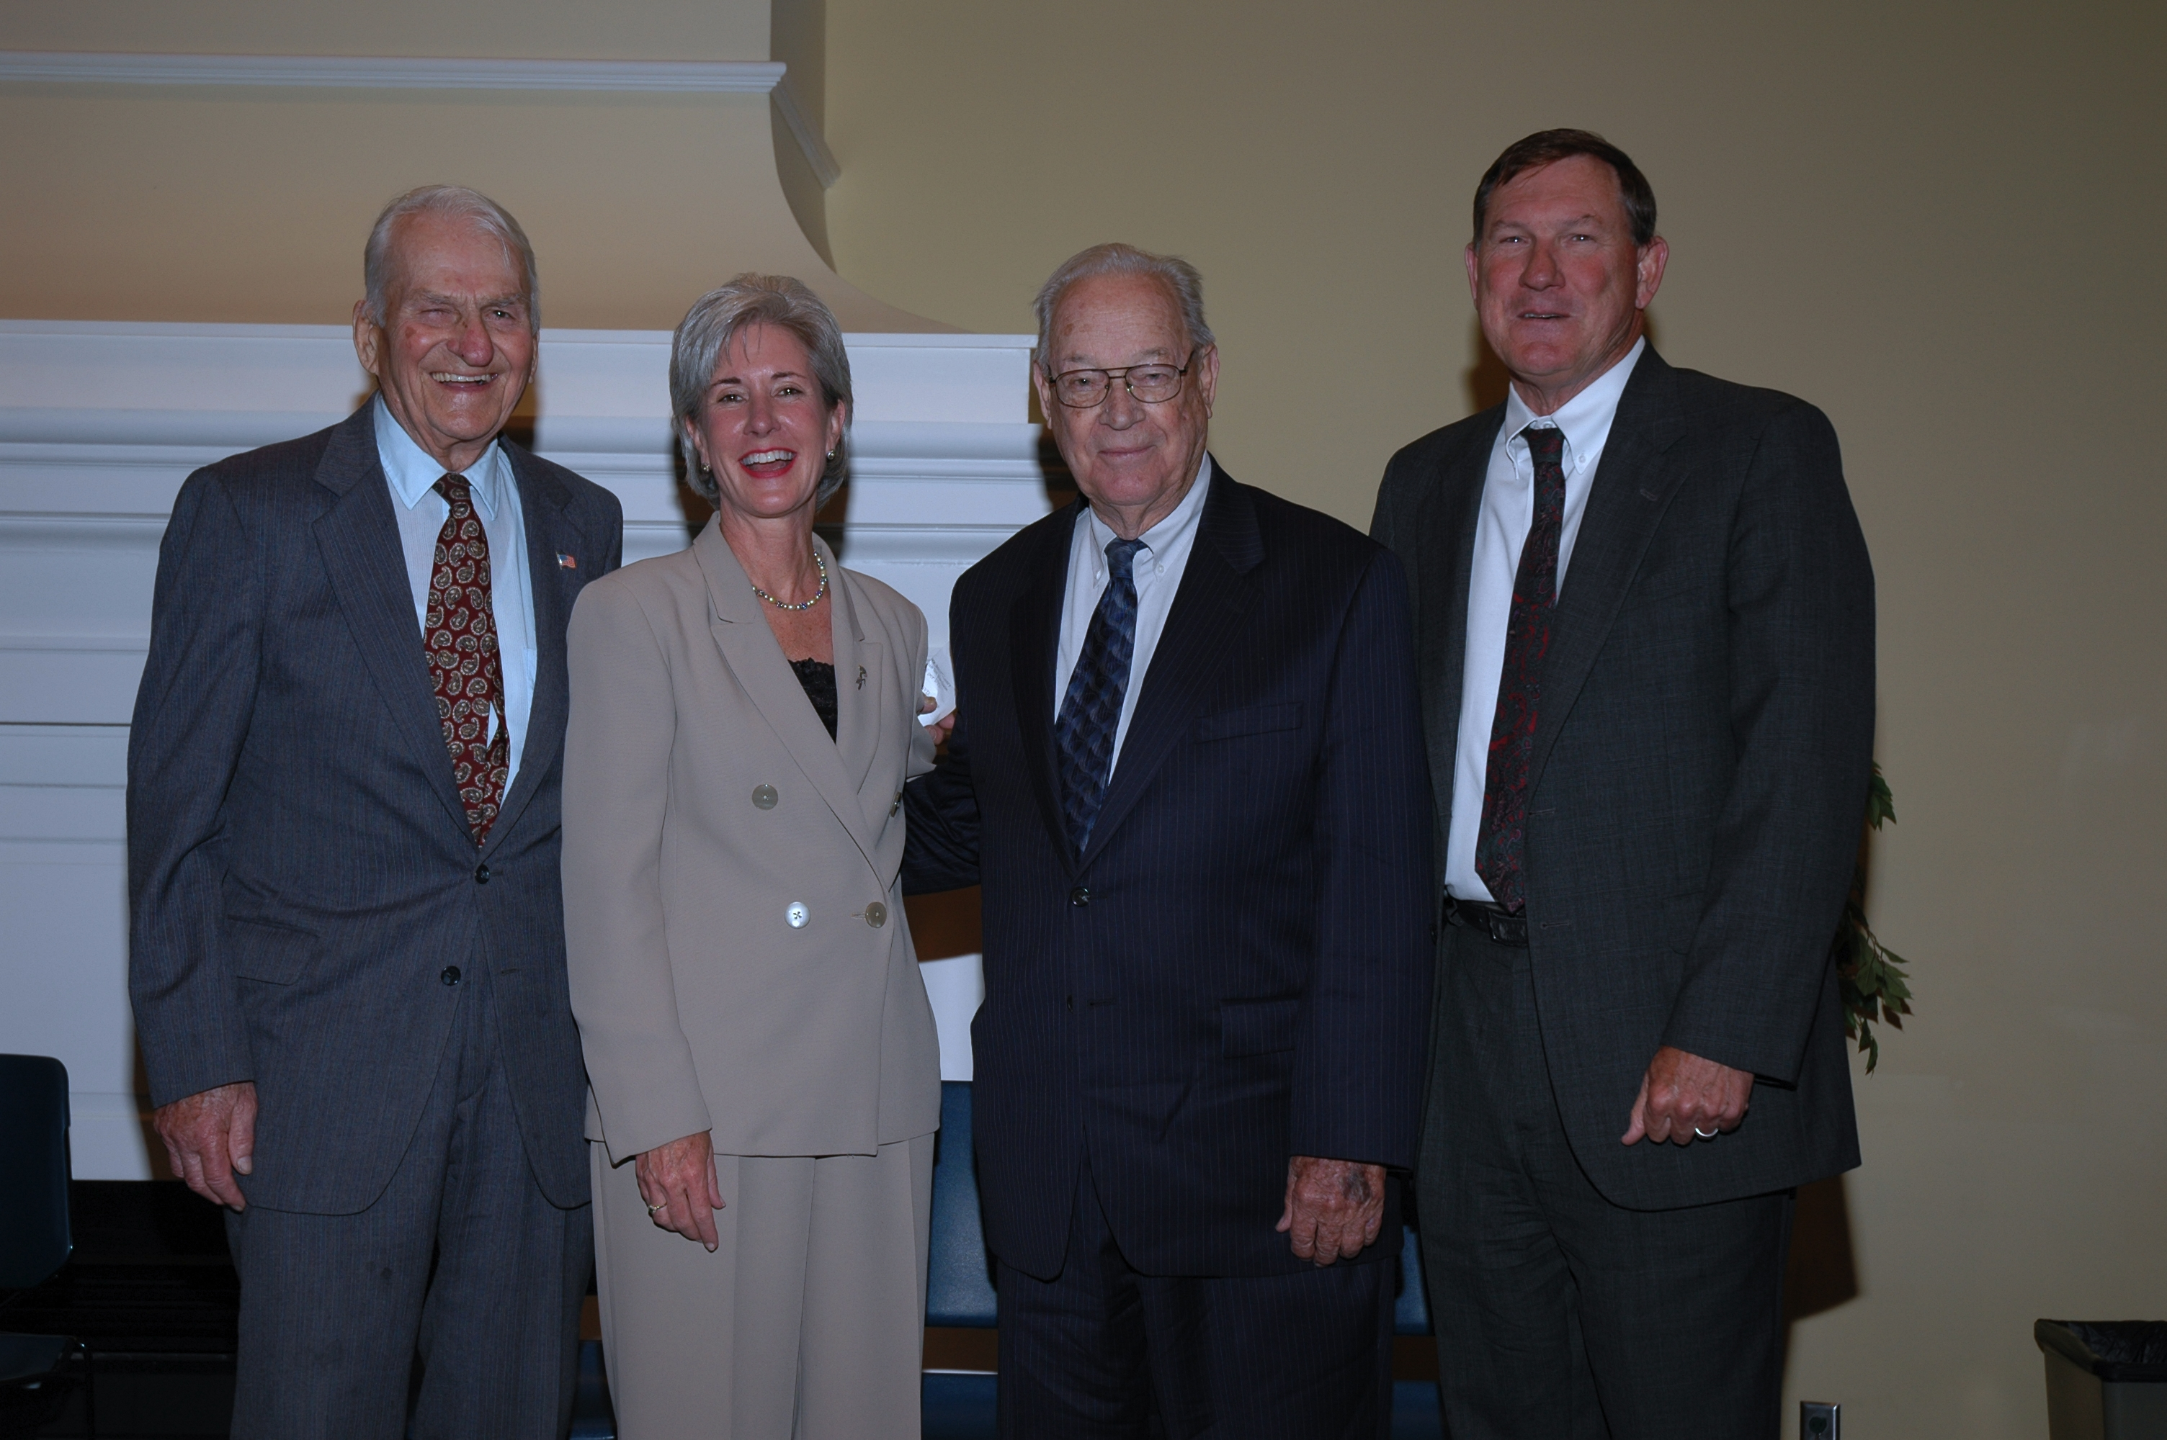
Kansas Governors: William Avery, Kathleen Sebelius, John Anderson, Mike Hayden
May 18, 2005. Washburn University, Topeka, Kansas.
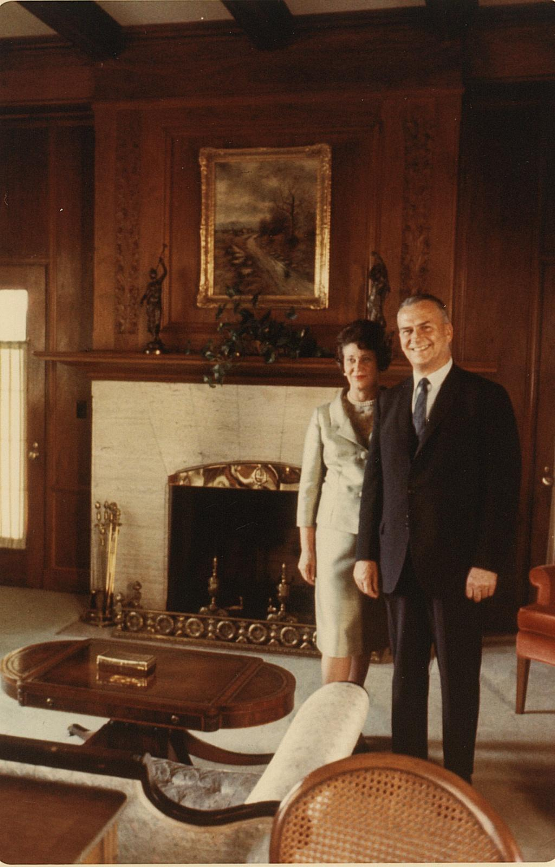
Governor William Avery and wife Hazel at Cedar Crest, 1967.

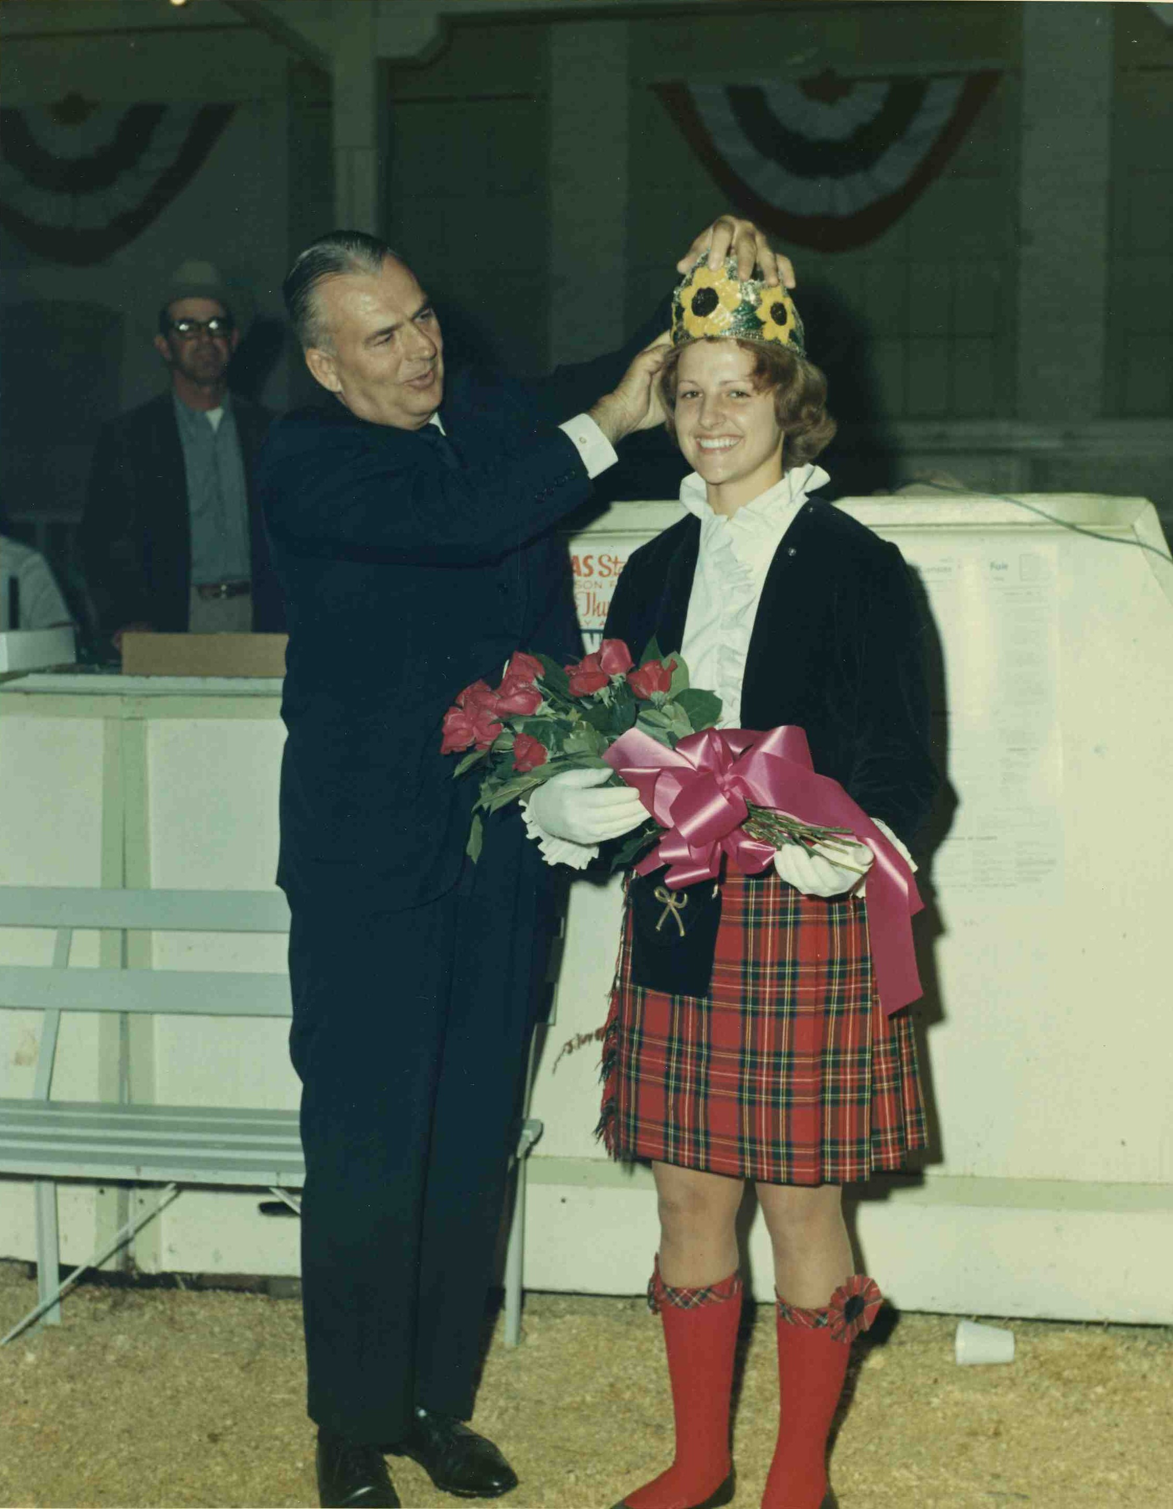
Governor William Avery, 1967.

