Washburn Windows 10 Virtual Desktop

VDI (or Virtual Desktop Infrastructure) is a service to access a working Windows 10 desktop by either of two methods -through a web browser or dedicated client software.
Log into Washburn’s virtual desktop here: https://vdi.washburn.edu
The recommended connection method is to use Chrome as the web browser. Once at the site you will be given the choice of using the Client (which must be installed and configured) or simply use HTML Access. The HTML method supports multiple clients from PC’s to Macs to tablets and will provide the best experience for a variety of user devices.
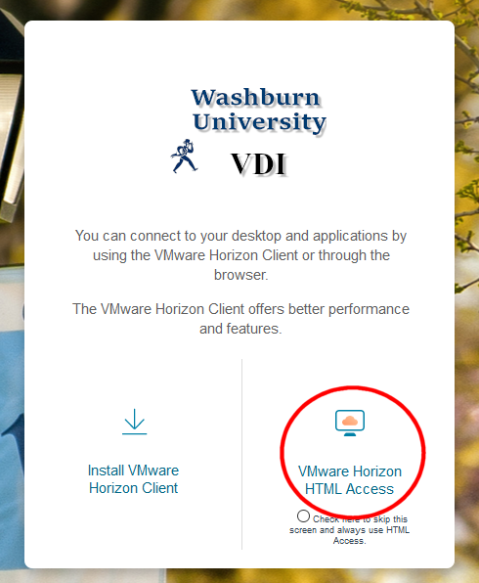

Click on HTML Access and you will be presented with a login page. Enter your Washburn credentials – first.last@washburn.edu and your email password.
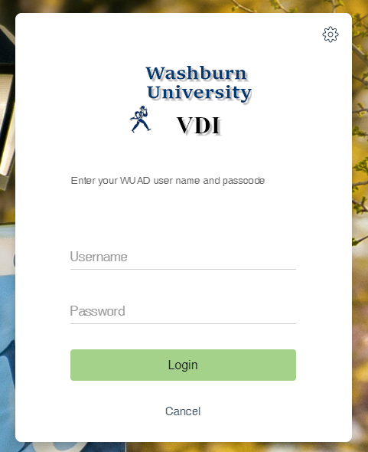
After you log in you will see an icon for either ‘Faculty and Staff’ or ‘Student’.
Click on the one that represents your role.
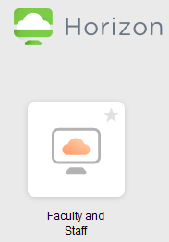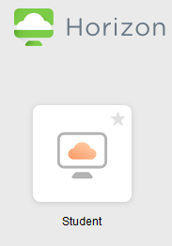

A standard Windows 10 startup screen will pop up displaying your name and the message - “Preparing Windows”.
After about 40 seconds the Windows 10 desktop is displayed. This desktop loaded with standard tools including Microsoft Office and Adobe Creative Suite.
Applications can be found by clicking on the Windows icon in the lower Left. Also your N: drive and S: drive are already mapped for you and accessible through Windows Explorer by clicking on the Yellow Folder in the task bar.

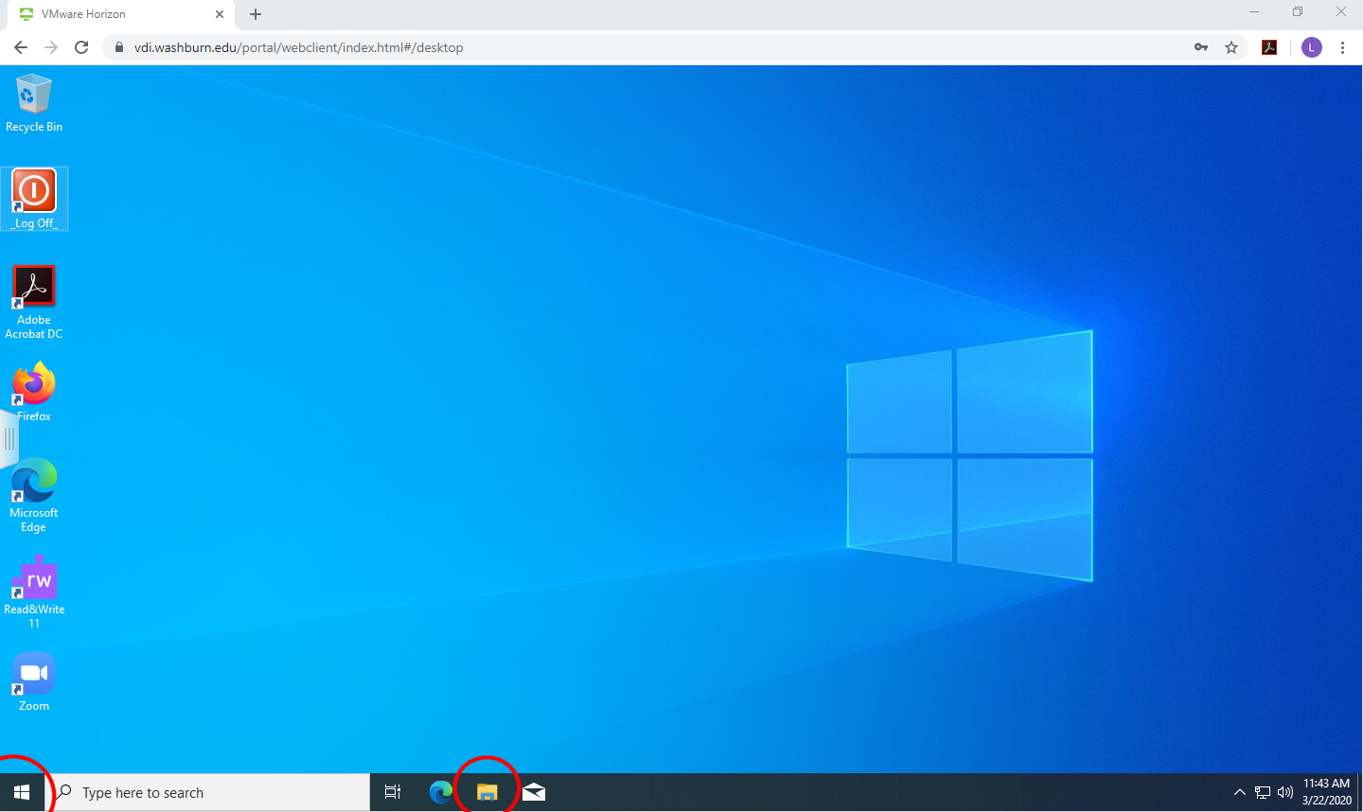

Please NOTE: You can only save files for future used on either the N: drive (your home directory) or the S: drive. Anything you save to the desktop is not persistent and will be lost once you end your session.
When you are finished with the virtual desktop, simply Double Click on the “Log Off” icon in the upper Left.

